**DATA SOFTIXS – INTERNSHIP**

**WEEK 1 : Crafting Your Digital Identity**

**PROJECT 1 : My Digital Portfolio**

**➢ Objective**: Design a responsive portfolio website to showcase

personal skills and achievements.

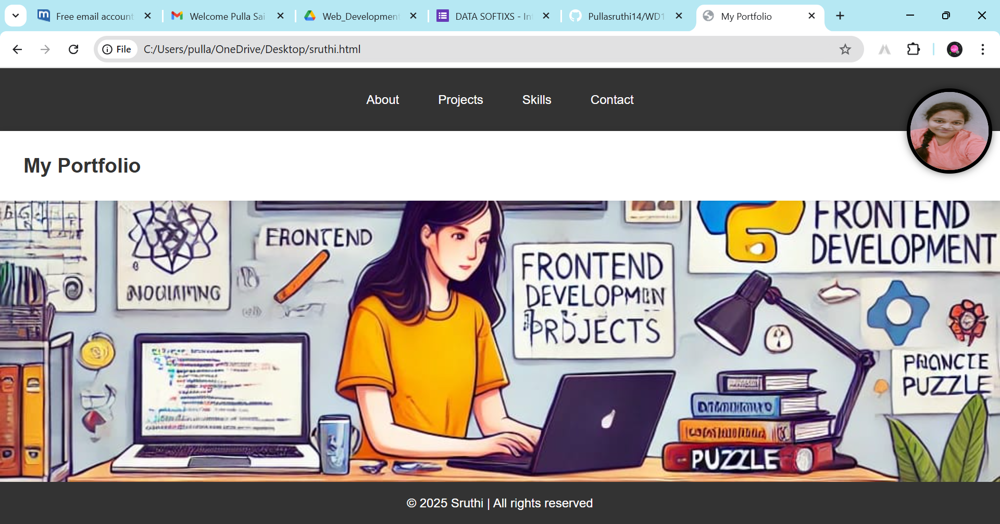

**➢ Key Features:**

**✓** Create sections for **About Me:**

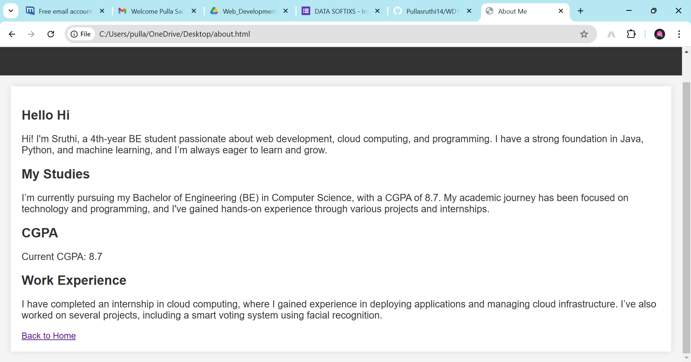

**Projects:**

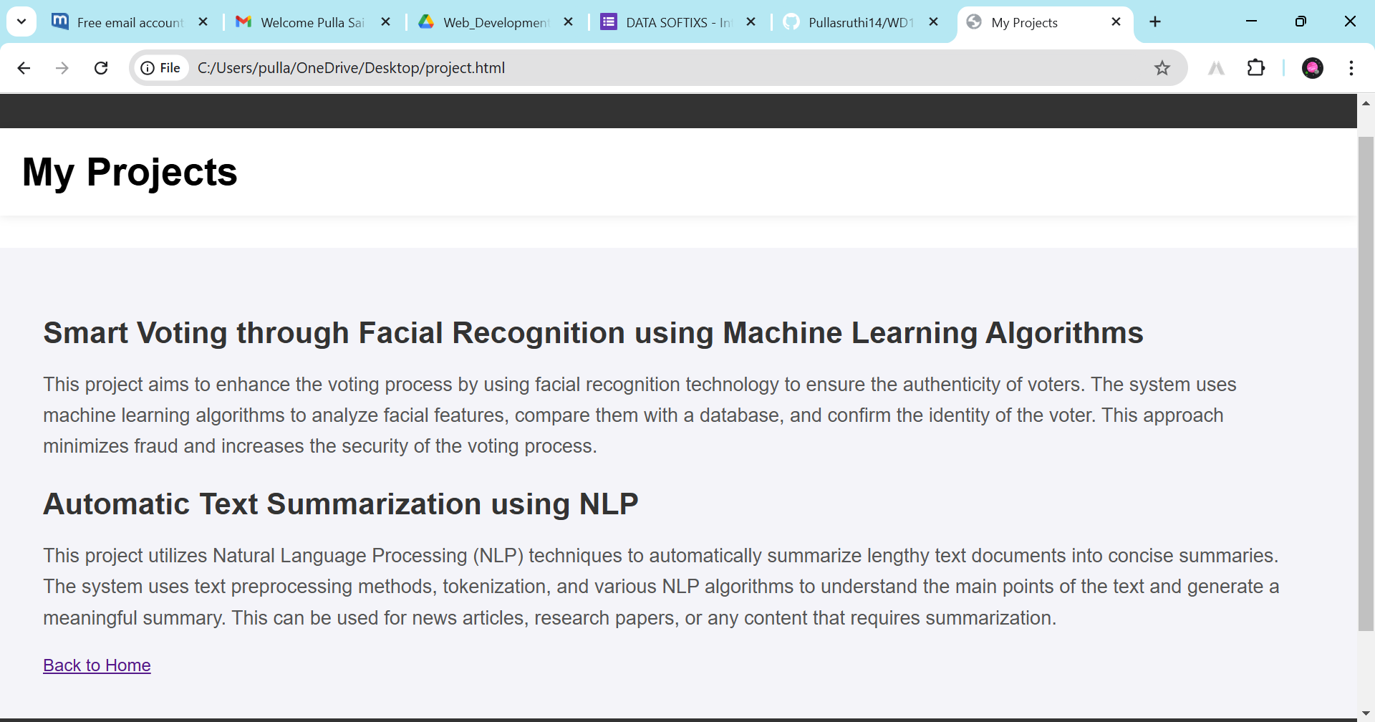

**Skills:**

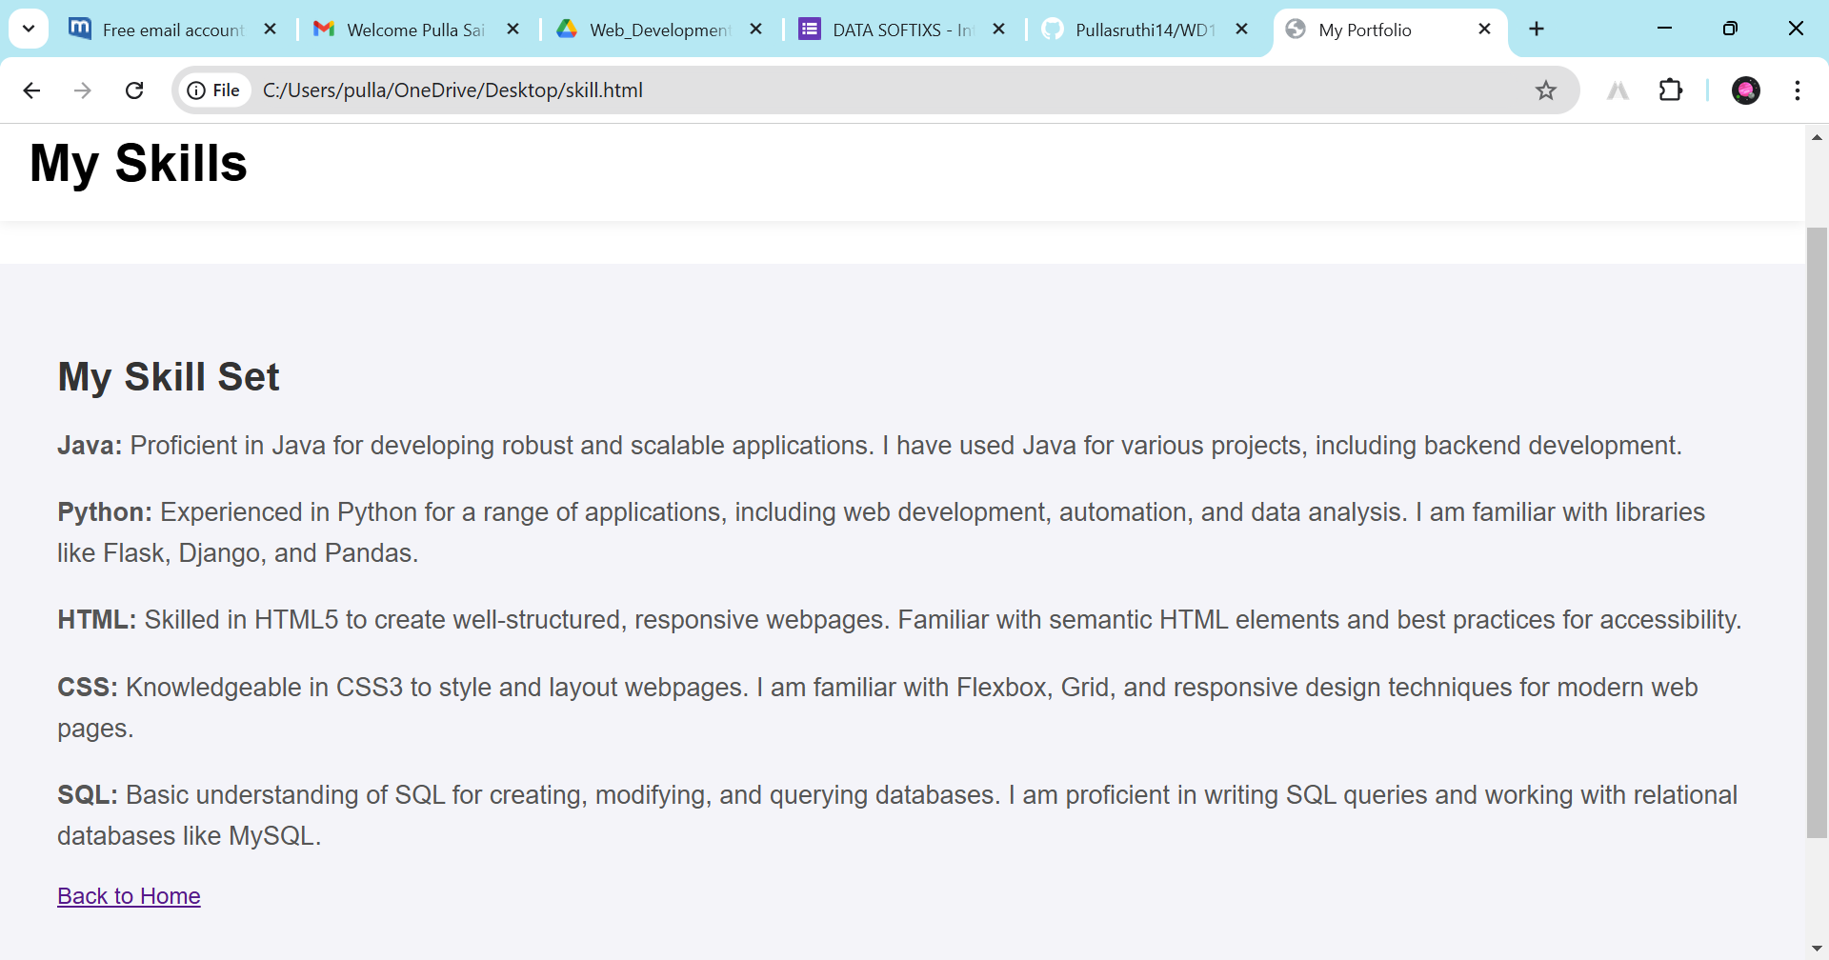

**Contact:**

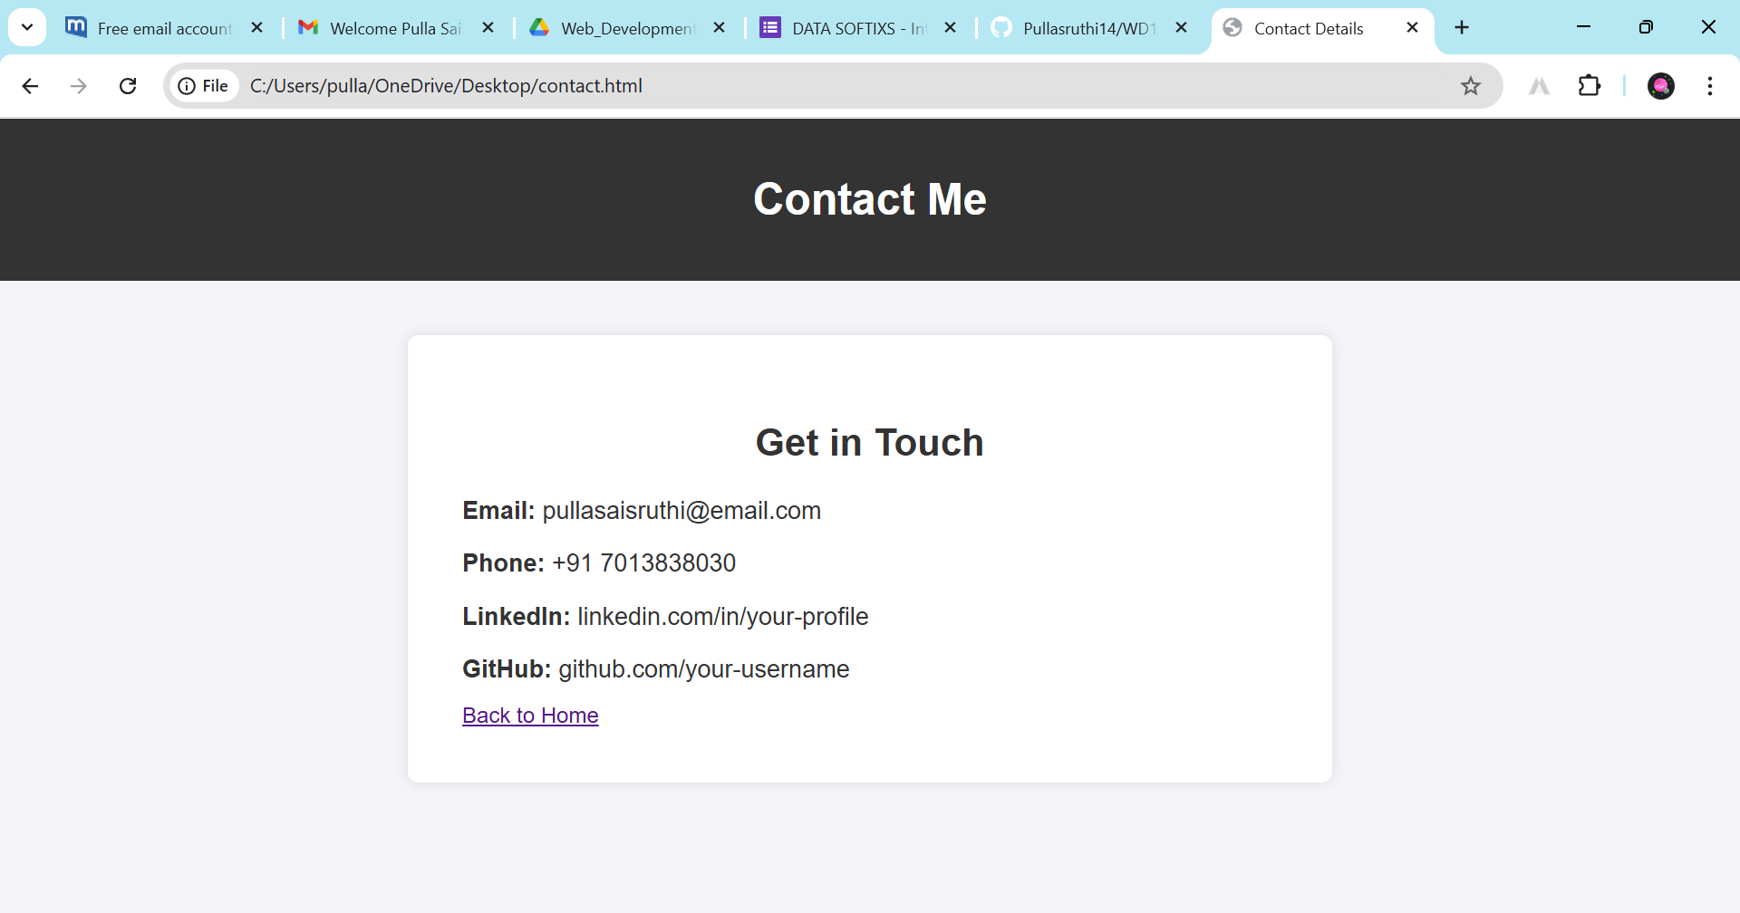

* This is the week 1 project about my portfolio. From this project Im sure about the giving my best .
* I learned Html ,CSS for creating this Web Application contains different styles and sheets and code using CSS.
* I built only the frontend of the my portfolio in that my details and projects and skills I present it through HTML.

**Week 2: Interactive Experiences**

**Project 3 : Task Manager**

**➢ Objective:** Develop a dynamic to-do list application.

**➢ Key Features:**

**✓** Allow users to add, mark complete, and delete tasks.

**✓** Use JavaScript to store tasks in local storage for persistence.

**✓** Style with CSS for an engaging look and feel.

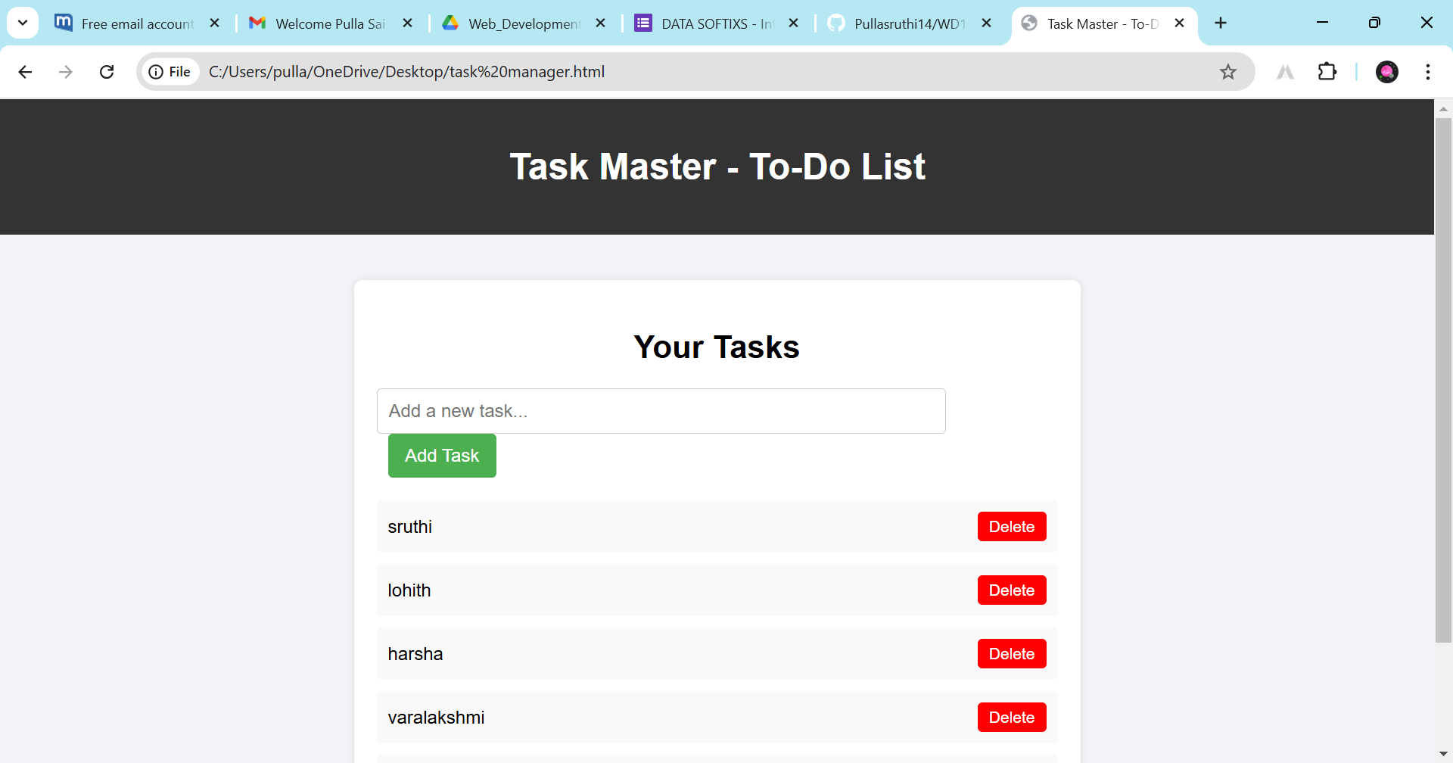

• **HTML Structure**

* Creating a form with an input field and a button for adding tasks.
* Using lists or div elements to display tasks dynamically.

• **CSS Styling**

* Designing a user-friendly interface with background colours, buttons, and proper spacing.
* Styling the "Add Task" and "Delete" buttons with different colours (green for add, red for delete).

**WEEK 3 : Bringing Ideas to Life**

**PROJECT 5 : Skywatcher's Companion**

**➢ Objective:** Design a weather dashboard that provides real-time

weather updates.

**➢ Key Features:**

**✓** Fetch and display weather details (e.g., temperature,

humidity, conditions) using an API.

**✓** Include a search bar for users to check weather by city.

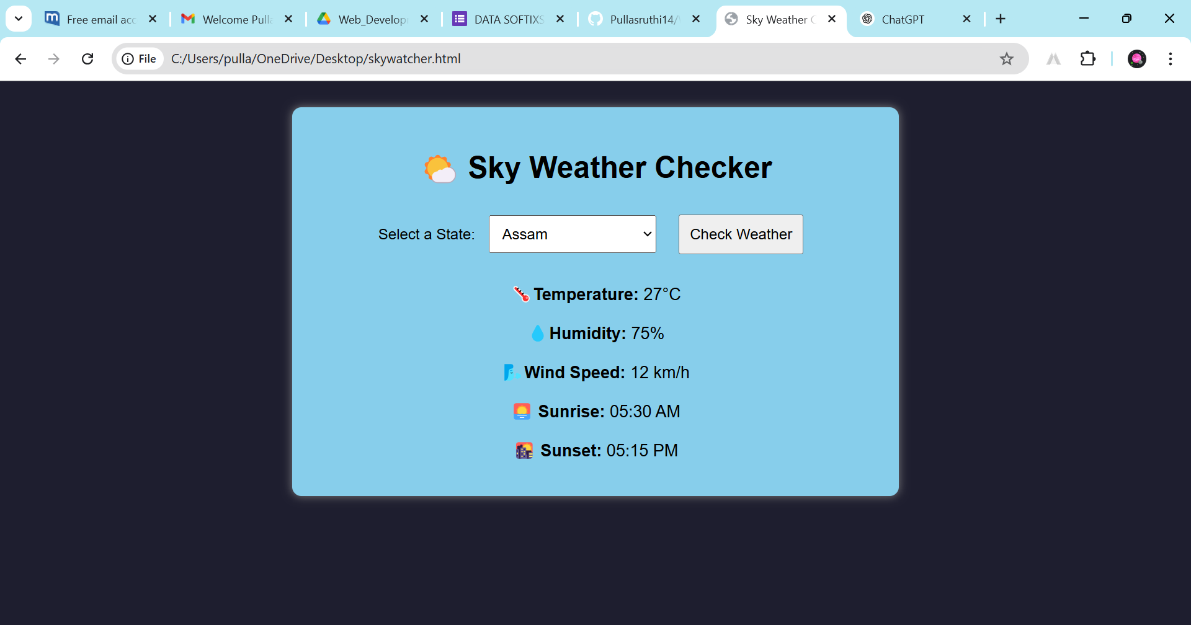

**HTML & Form Handling**

* Creating a dropdown menu to select a state.
* Adding a button to trigger weather fetching.
* Using icons to enhance UI readability.

**2. CSS Styling & UI Design**

* Designing a responsive and visually appealing UI.
* Using background colors, padding, margins, and borders for better user experience.
* Adding rounded corners and shadows for a modern look.

**3. JavaScript & API Integration**

* Fetching weather data dynamically when the user clicks "Check Weather".
* Displaying weather parameters like temperature, humidity, wind speed, sunrise, and sunset time.
* Handling state selection and API requests to get location-based weather data.

**Code:** Highlight key sections of your code.

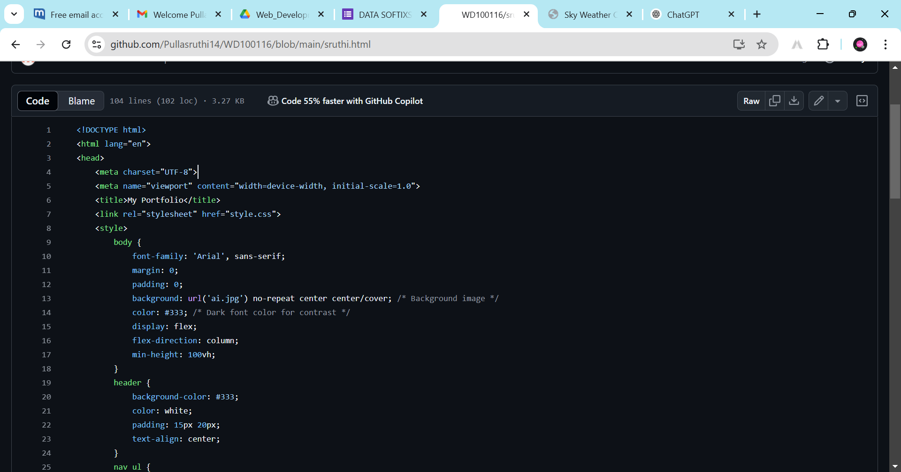

▪ **Explanation:** Provide a brief description of how your project works.

**WEEK 3 :**

* The **Sky Weather Checker** is a simple web application that allows users to check real-time weather conditions for different states. The user selects a state from a dropdown menu and clicks the **"Check Weather"** button. The application then retrieves and displays key weather details, including:

🌡️ **Temperature**

💧 **Humidity**

🌬️ **Wind Speed**

🌅 **Sunrise Time**

🌇 **Sunset Time**

The UI is designed with a clean and modern look, featuring icons for better readability. The weather data is likely fetched using a **weather API**, and JavaScript is used for **DOM manipulation** to update the weather details dynamically.

**WEEK 1 :**

* My portfolio showcases my skills in **frontend development, web design, and cloud computing**. It includes projects like:
* **To-Do List App** – A task management tool with dynamic updates.
* **Sky Weather Checker** – A weather app fetching real-time data.
* **Smart Voting System** – A facial recognition-based voting system (ML project).
* I have expertise in **HTML, CSS, JavaScript, Python, cloud computing, and ethical hacking**, with certifications in **Java and Python**. My portfolio highlights my passion for building user-friendly web applications.

**▪ Tools & Technologies Used**

**1. Programming Languages:**

HTML, CSS, JavaScript – For structuring and styling the frontend.

Python – For backend logic (if applicable).

**2. Libraries & Frameworks:**

Bootstrap – For responsive UI design.

jQuery – For easy DOM manipulation (if used).

**3. Tools & Platforms:**

VS Code – For coding and debugging.

Git & GitHub – For version control.

Chrome Dev Tools – For debugging and testing

▪ **Output Result Screenshots:**

**WEEK 1:**



**WEEK 2:**



**WEEK 3:**



**PULLA SAI SRUTHI**

**CSE , FINAL YEAR**

**@Datasoftixs**